
Koneru Lakshmaiah Education Foundation
(Deemed to be University estd. u/s. 3 of the UGC Act, 1956)
Off-Campus: Bachupally-Gandimaisamma Road, Bowrampet, Hyderabad, Telangana - 500 043. Phone No: 7815926816, www.klh.edu.in

STUDENT CASE STUDY EXECUTION REPORT
Department | FED
Sub'ect | DSA-2
Academic Year | 1-III Semester | 2025-26
Facult Name | Mohd.Razia
Student Name | S.Sai Snehith
Roll Number | 2520090149
Branch | CSIT
Course Outcome | CO-5
Case Study Topic: Streaming Request Scheduling using Priority Queue
Work Done Summary:
In this case study, we implemented a Priority Queue to manage streaming requests in the Media Vault platform. User requests were assigned priorities based on subscription level, streaming quality, and request time. The Priority Queue ensured that high-priority users received faster service and reduced streaming delays.
Various streaming requests were inserted, processed, and removed according to their priorities. The system efficiently handled large numbers of requests while maintaining smooth streaming performance.
Implementation Details:
1) Created a Priority Queue for streaming request management.
2) Assigned priorities based on subscription plans.
3) Inserted user streaming requests into the queue.
4) Processed requests according to priority order.
5) Implemented request removal after streaming completion.
6) Compared Priority Queue performance with normal queue processing.
7) Verified efficient scheduling and reduced waiting time.
.

Result: Screenshots / Output
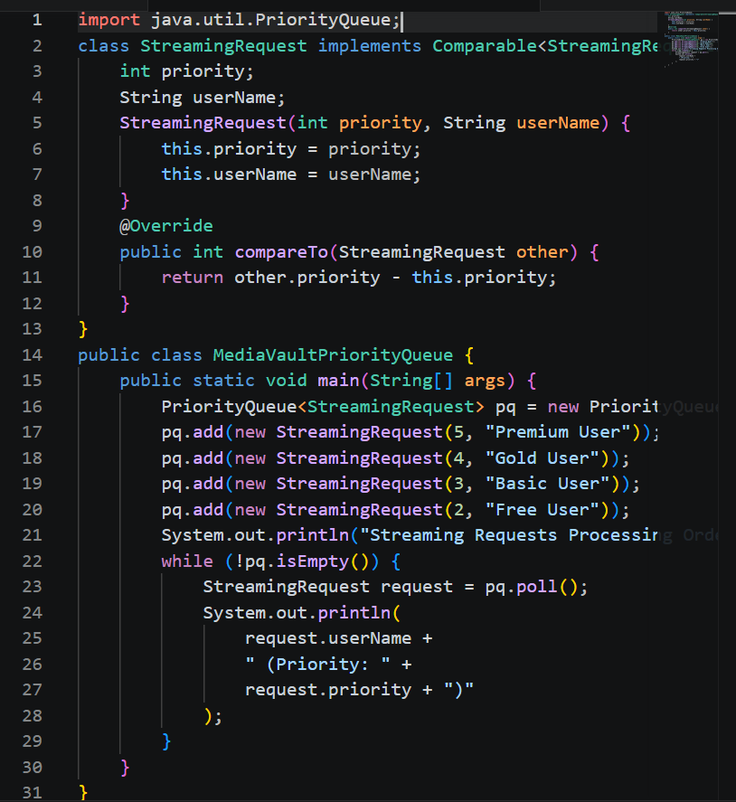
Output:-
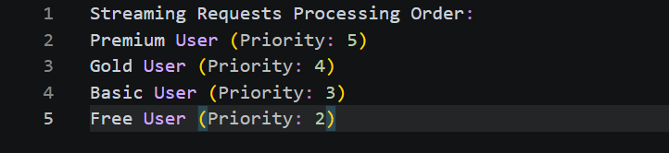

.
The Priority Queue successfully managed streaming requests and ensured faster service for premium users. The system reduced response time and improved overall streaming efficiency.
GitHub Link: https://github.com/snehiths399-byte/MediaVault--Digital-content-streaming-and-Analytics-system/blob/main/Priority%20Queue
Student Signature Faculty Signature

